**Git Installation and its steps**

Git Packages version:--

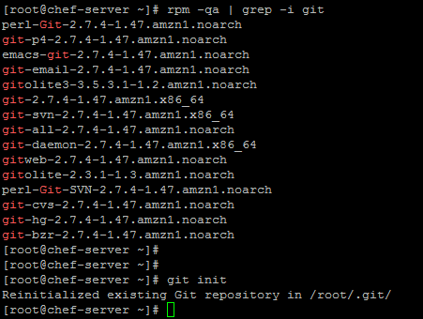

Directory structure of git:-

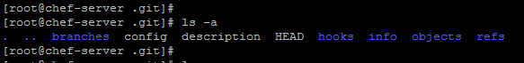

Adding the new files under git environment



Now to check new file is added,

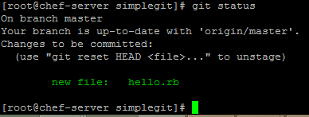

#git status

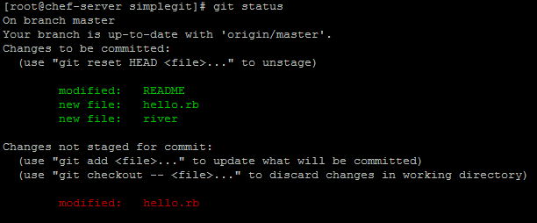

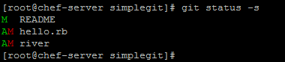

AM --means that the file has been modified on disk since we last added it. This means that if we commit our snapshot right now, we will be recording the version of the file when we last ran git add, not the version that is on our disk.

* git diff shows diff of what is staged and what is modified but unstaged

# git diff

Show you the changed in your file since the last commit but not yet in staged

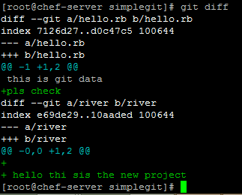

Here I have edited “river” files and new line printed in the bottom.

# git diff –cached --->>> diff of staged changes

# git diff HEAD ---- >>> Showing diff of staged and upstaged changes

# git diff –stat ---- >>> Summary data for above cmd

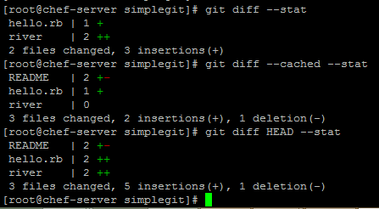

* git commit records a snapshot of the staging area

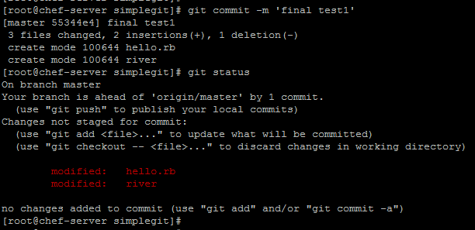

* git reset undo changes and commit

# git reset --hard HEAD --- >>> while we had both changes ready to commit and ready to stage, then this is wiped them out.

* git stash add current changes to the stack

# git stash

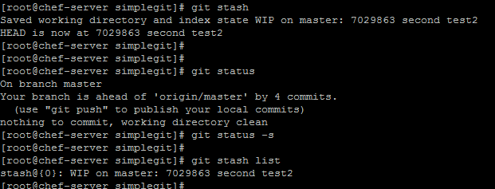

* git branch list your available branches

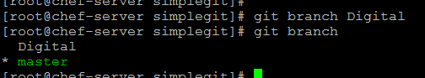

* # git branch -v :- see the last commit on each branch

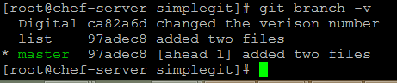

# git checkout -b titan -- >>> create and immediately switch to a branch